**ROC-RK3588S-PC Test to Evaluate Performance of CPU, GPU, FPS, Memory and Temperature**

**ROC-RK3588S-PC测试，评估CPU、GPU、FPS、内存和温度的性能**

**Benchmark Performance Score /基准绩效分数：**

|  |  |  |  |  |
| --- | --- | --- | --- | --- |
| **Benchmark Software**  **基准软件** | **Geekbench 5** | **3DMark** | **AnTuTu** | **PassMark** |
| **CPU Score /** CPU分数 | 单核  Single-Core 474  多核 Multi-Core 2113 | 3541 | 143660 | 2775 |
| **GPU Score /** GPU分数 | OpenCL: 3875  Vulkan: 3961 | 9048 | 248098 | 2D Test/二维测试: 16894  3D Test/三维测试: 76,526 |
| **Memory Score /记忆分数** |  |  | 140974 | 7706 |
| **UX Score /** UX 分数 |  |  | 106400 |  |
| **Overall Score /平均得分** |  | 6724 | 639132 |  |
| **GPU TEST 1 /** GPU测试1 |  | 46.6 帧速率(FPS) |  |  |
| **GPU TEST 2 /** GPU测试2 |  | 34.1帧速率(FPS) |  |  |
| **CPU TEST 1 /** CPU测试1 |  | 51.8帧速率(FPS) |  |  |
| **CPU TEST 2 /** CPU测试2 |  | 34.3帧速率(FPS) |  |  |
| **CPU TEST 3 /** CPU测试3 |  | 21.7帧速率(FPS) |  |  |
| **Overall Frame Rate**  **总帧速率** |  | 20 to 61帧速率(FPS) |  |  |
| **CPU clock (GHz)**   * cpu频率 |  | 0.4 GHz to 2.0 GHz |  |  |

**RK3588S-PC Temperature before and after running test software**

**运行测试软件前后RK3588S-PC的温度**

|  |  |  |  |  |  |  |  |  |
| --- | --- | --- | --- | --- | --- | --- | --- | --- |
| Temperature  温度 | SoC | BigCore0 | BigCore1 | Little-core | Center | GPU | NPU | CPU |
| Before Testing  测试前温度 | 31.5 °C | 30.5 °C | 31.5 °C | 31.5 °C | 30.5 °C | 30.5 °C | 31.5 °C | 30.5 °C |
| During and after testing  测试期间和之后的温度 | 31.5 °C | 30.5 °C | 31.5 °C | 31.5 °C | 30.5 °C | 31.5 °C | 31.5 °C | 31 °C |

**ROC-RK3588S-PC and RK3399PRO performance evaluation based on below benchmark software: 基于以下基准软件的ROC-RK3588S-PC和RK3399PRO性能评估：**

1. **Geekbench**
2. **3DMark**
3. **Antutu**
4. **Passmark**

* 评估CPU、GPU、FPS、内存和温度的性能
* Temperature results /温度结果
* 单核和多核性能 / Single- and multi-core performance
* As shown in the figure below, the **ROC-RK3588S-PC** has a much higher benchmark performance score than the RK3399PRO /如下图所示，**ROC-RK3588S-PC**的基准性能得分远高于RK3399PRO
* The RK3399PRO has a very low frame rate and lags when processing high-resolution video. It also has a heating problem. / **RK3399PRO**帧速率非常低，在处理高分辨率视频时存在滞后。它还存在加热问题。
* The **ROC-RK3588S-PC** can easily support high-resolution video without lag issues and heat issues. It has a heating control system and a high frame rate. / ROC-RK3588S-PC可以轻松支持高分辨率视频，并且没有滞后问题和发热问题。它有加热控制系统，帧速率也很高。

1. **Geekbench 5**

**CPU benchmark**

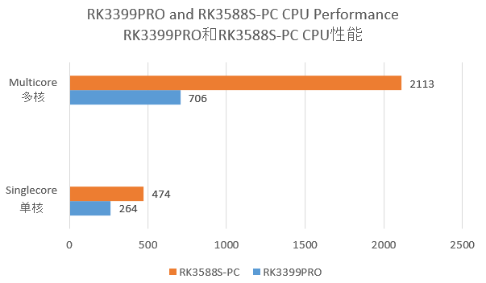

**GPU benchmark**

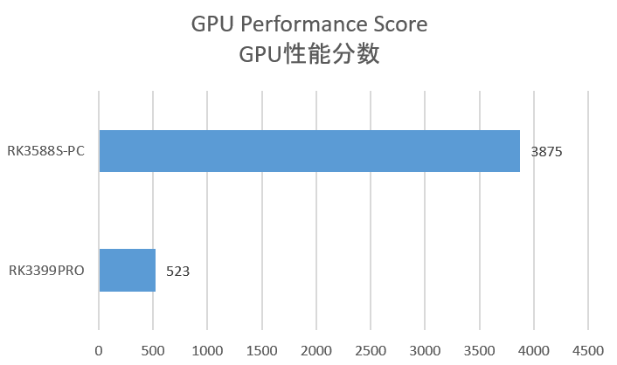

1. **3DMark**

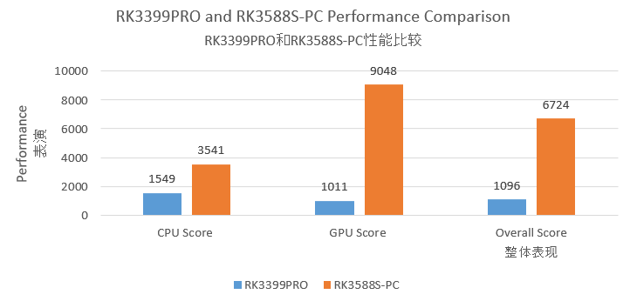

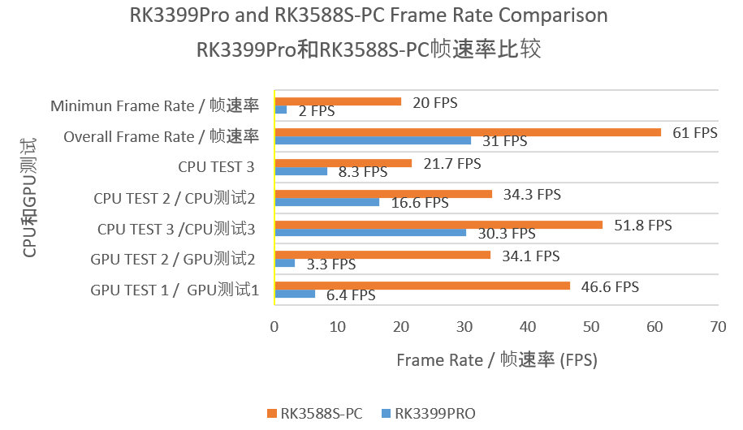

1. **Antutu**

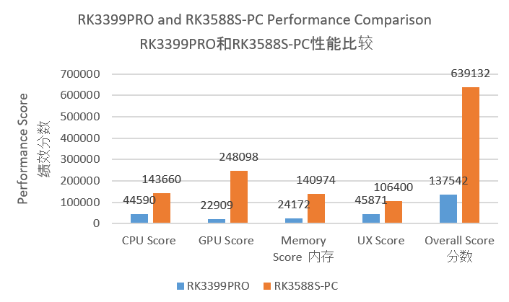

1. **Passmark**

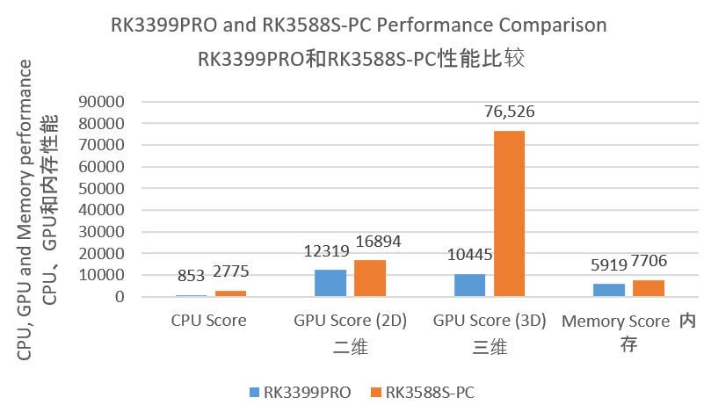

1. **Temperature Results**

**Temperature comparison of RK3399PRO and RK3588S-PC before running the testing software**

**运行测试软件前RK339Pro和RK3588S-PC的温度比较**

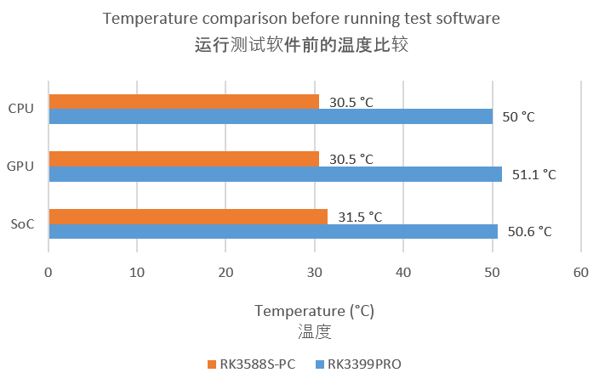

**Temperature comparison of RK3399PRO and RK3588S-PC during and after running the testing software. 运行测试软件期间和之后RK339Pro和RK3588S-PC的温度比较**

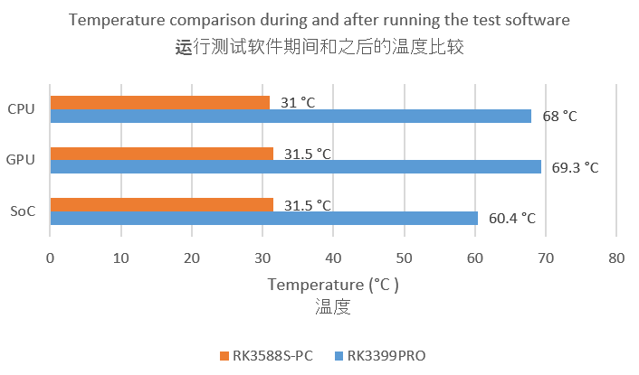

**Conclusion:**

* This report contains test results of ROC-RK3588S-PC
* We have Evaluated performance of CPU, GPU, NPU, FPS, Memory and Temperature.
* We have used below benchmark software:
* Geekbench 5
* 3DMark
* AnTuTu
* PassMark
* We have compared the results of ROC-RK3588S-PC and RK3399PRO
* The benchmark performance results of ROC-RK3588S-PC are much higher than RK3399PRO
* RK3399PRO has heating problem. Temperature of CPU, GPU and SoC is high. Its temperature range is 50 to 70 °C which is very bad.
* ROC-RK3588S-PC control the temperature so it has no heating problem. Its temperature range is 30 to 32 °C which is very good.
* ROC-RK3588S-PC has no lagging in the high resolution video. It can support 4K and 8K videos. Its frame rate (FSP) range is high 20 to 61 so its video performance is much better than RK3399PRO.
* RK3399PRO has only 2 to 20 frame rate (FPS) range

**结论：**

* 本报告包含ROC-RK3588S-PC的测试结果
* 我们评估了CPU、GPU、NPU、FPS、内存和温度的性能。
* 我们使用了以下基准软件：
* Geekbench 5
* 3DMark
* AnTuTu
* PassMark
* 我们比较了ROC-RK3588S-PC和RK3399PRO的结果
* ROC-RK3588S-PC的基准性能结果远高于RK3399PRO
* RK3399PRO存在加热问题。CPU、GPU和SoC的温度较高。它的温度范围是50到70℃，这是非常糟糕的。
* ROC-RK3588S-PC控制温度，因此不会出现加热问题。其温度范围为30至32℃，非常好。
* ROC-RK3588S-PC在高分辨率视频中没有滞后。它可以支持4K和8K视频。它的帧速率（FSP）范围高达20到61，因此其视频性能远远优于RK3399PRO。
* RK3399PRO只有2到20帧速率（FPS）范围